**Report: ETL Jobs in Talend**

**Group 16**

**Nishita Shewale (002767947)**

**Siddharth Pawar (002225020)**

**Ritik Gupta (002102556)**

**Sakshi Aade (002813258)**

**Dimensional Model**

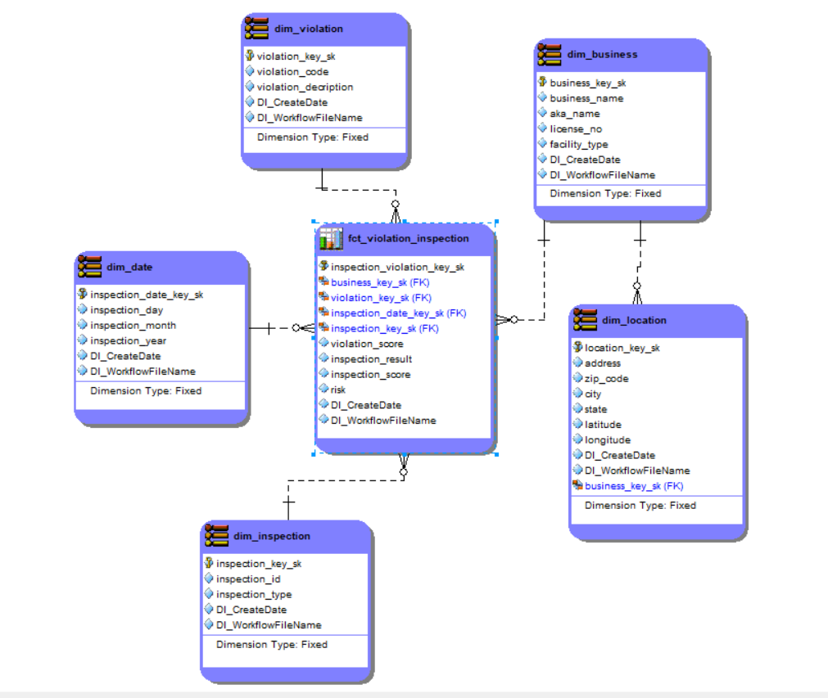

**Identified Dimensions:** Business Name, Inspection Details (Name kept as inspection), Violation Details (Name kept as Violation), Date, Location

**Grain:** As per Business requirements, we do not require Time-period Data but we have kept the granularity as “Daily” which can also be adjusted on the Bi dashboards using Drilldown and Drill-up arrows.

**Facts:** We are taking into consideration the values of risk, final_inspection_result, total_violation_score (which are calculated column) as the main results of the inspection.

**Chicago data transformation**

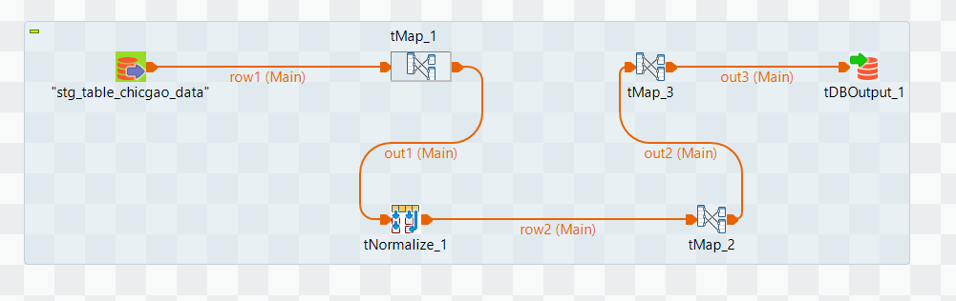

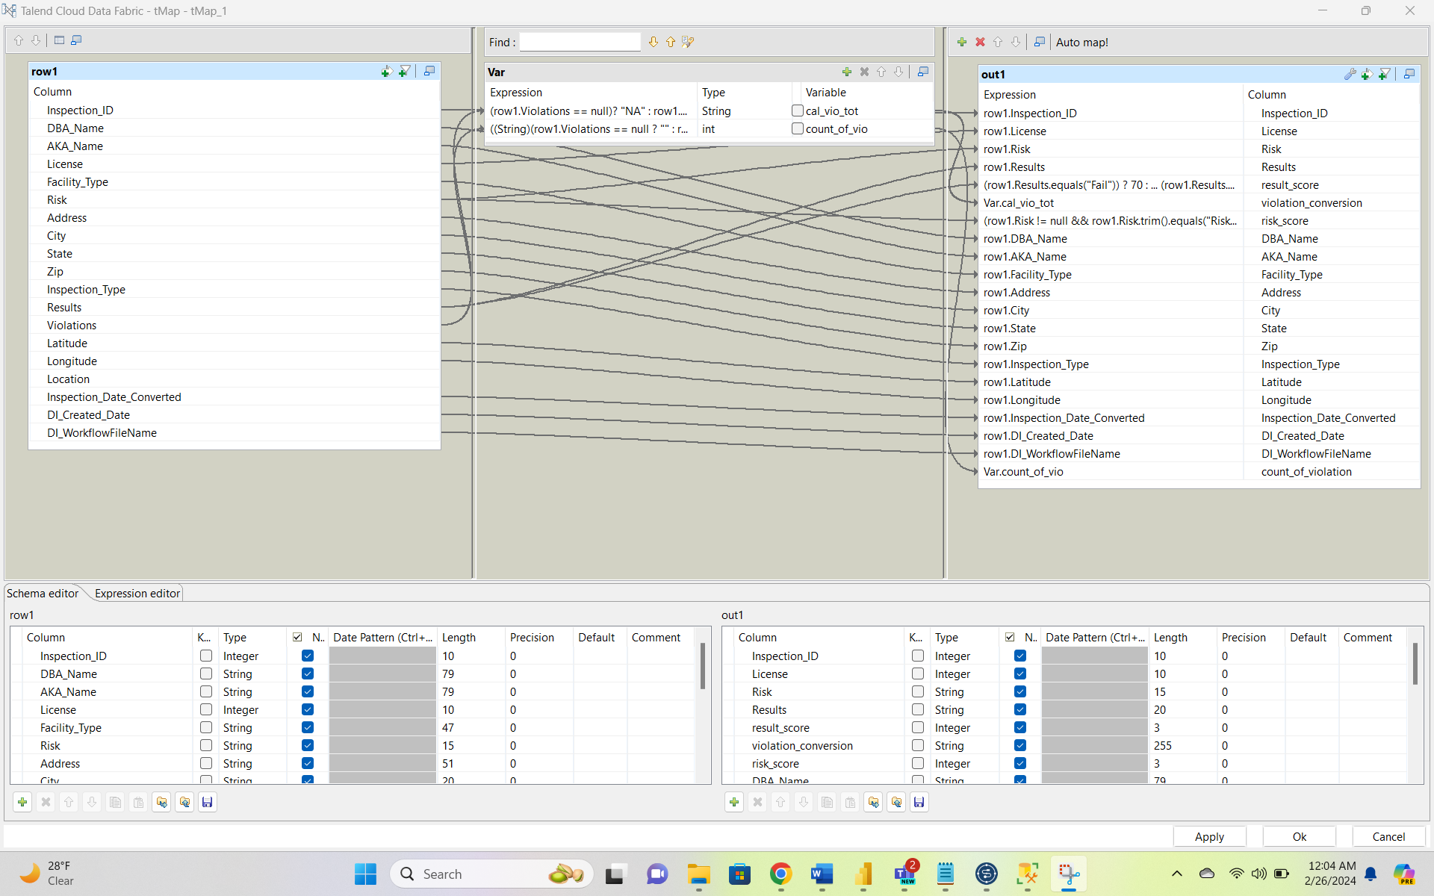

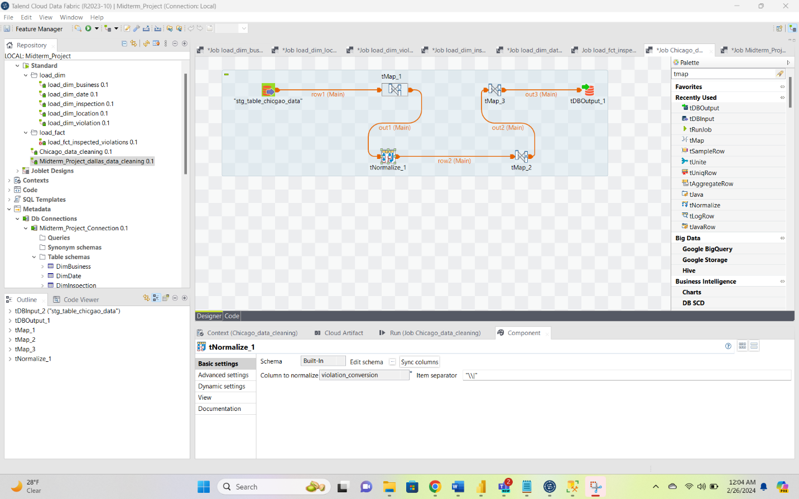

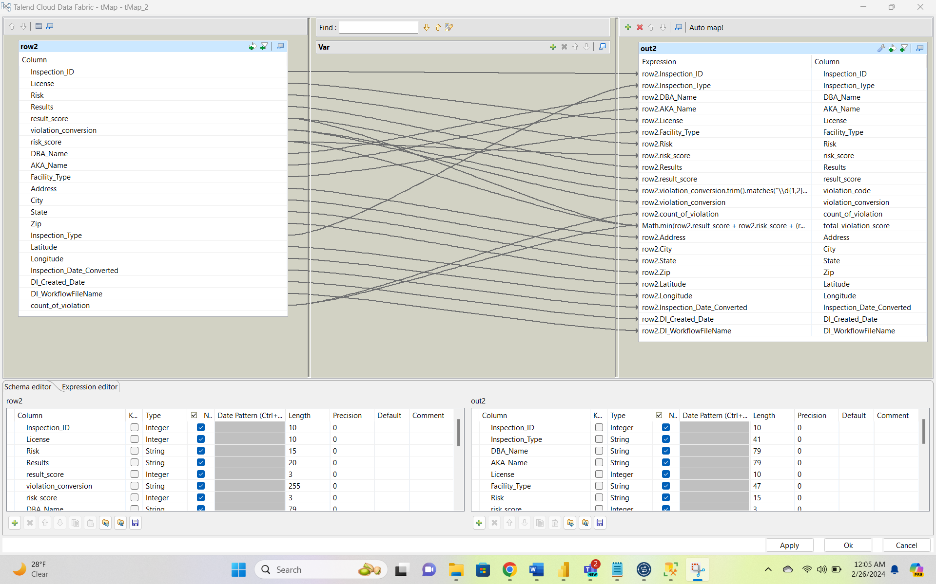

1. Fetched the count of all violations associated to a distinct record.
2. Normalized the Violation-Description data using TNormalize tool and “|” as the separator.
3. Used the Results column to calculate the result_score by implementing if else condition.
4. Used the risk column to calculate the risk_score by implementing if else condition.
5. Now calculated (2*count of violations + risk_score + result_score = total_violation_score) (as per instructions mentioned on slack)
6. Used the TMap to map the other attributes and loaded this data into a new SQL table.

**Dallas Data Transformation**

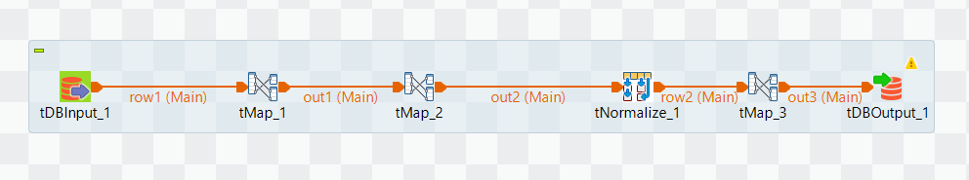

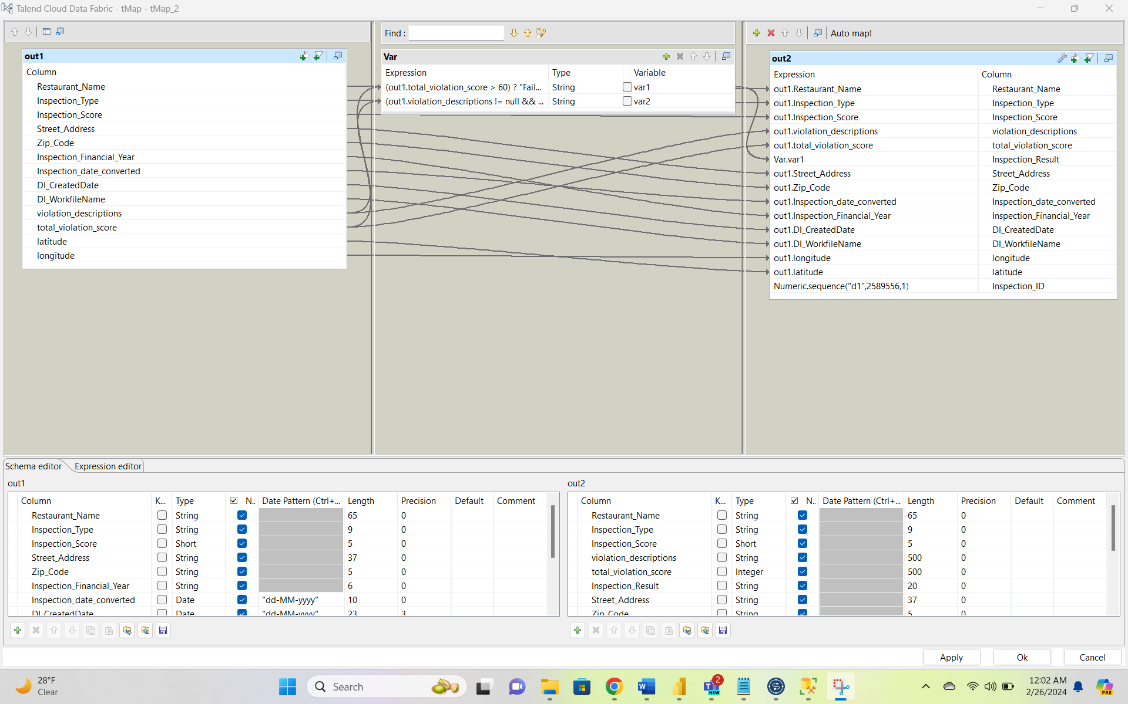

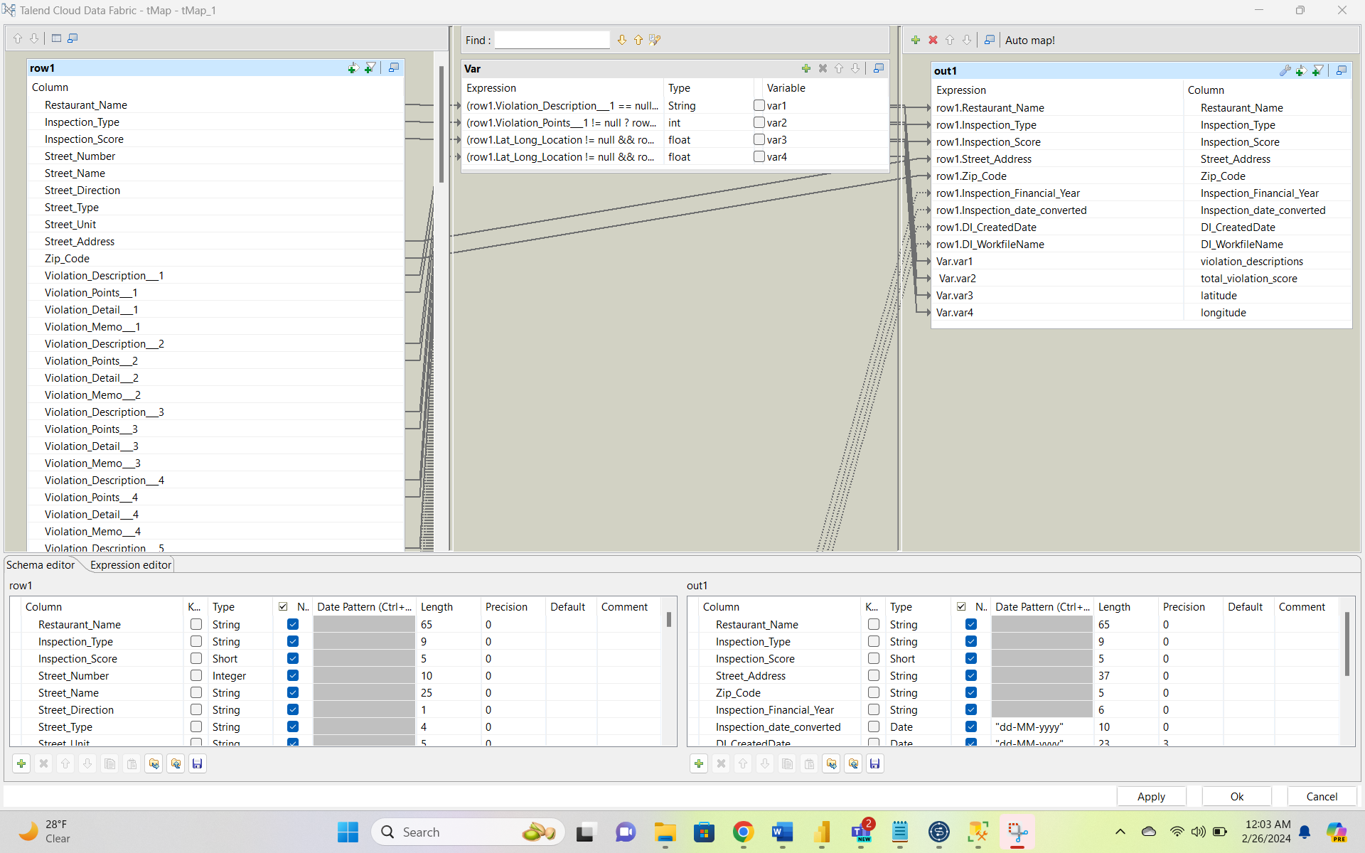

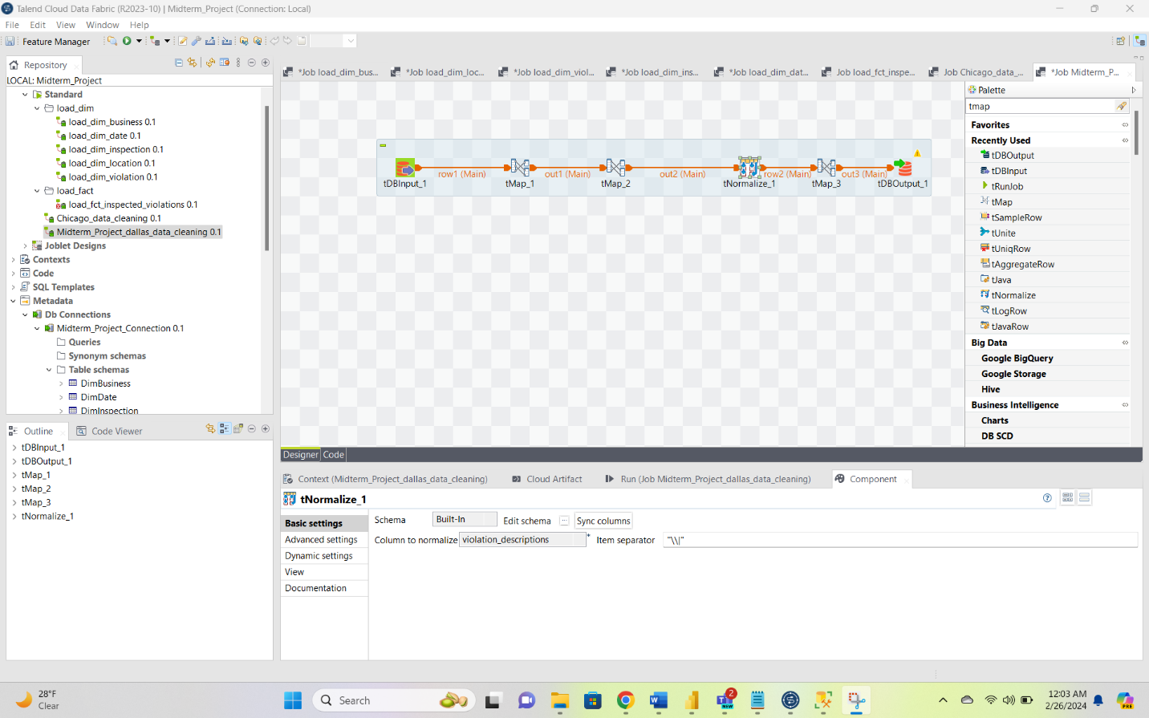

1. Calculated the total_violation_score by adding all the violation points associated with a record and then multiplied it by 2
2. Concatenated the violation_description columns associated with a record by using the | and later used TNormalize tool to break the value into 25 different rows.
3. Dropped the columns street direction, street name, street unit etc as the street_address column was itself a concatenated string of all of them. Also dropped violation_memo as it was not a part of business requirements.
4. Split the Lat Long Loc column by dropping the address off it and then splitting Latitude and Longitude as 2 different columns.

**Loading of DimLocation**

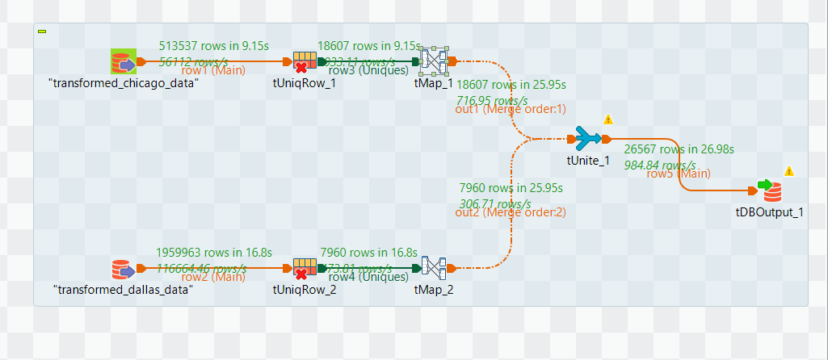

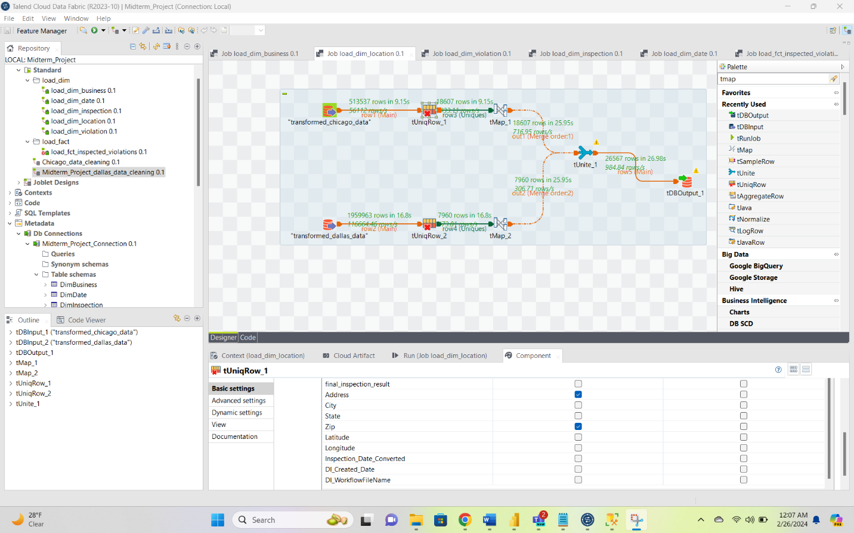

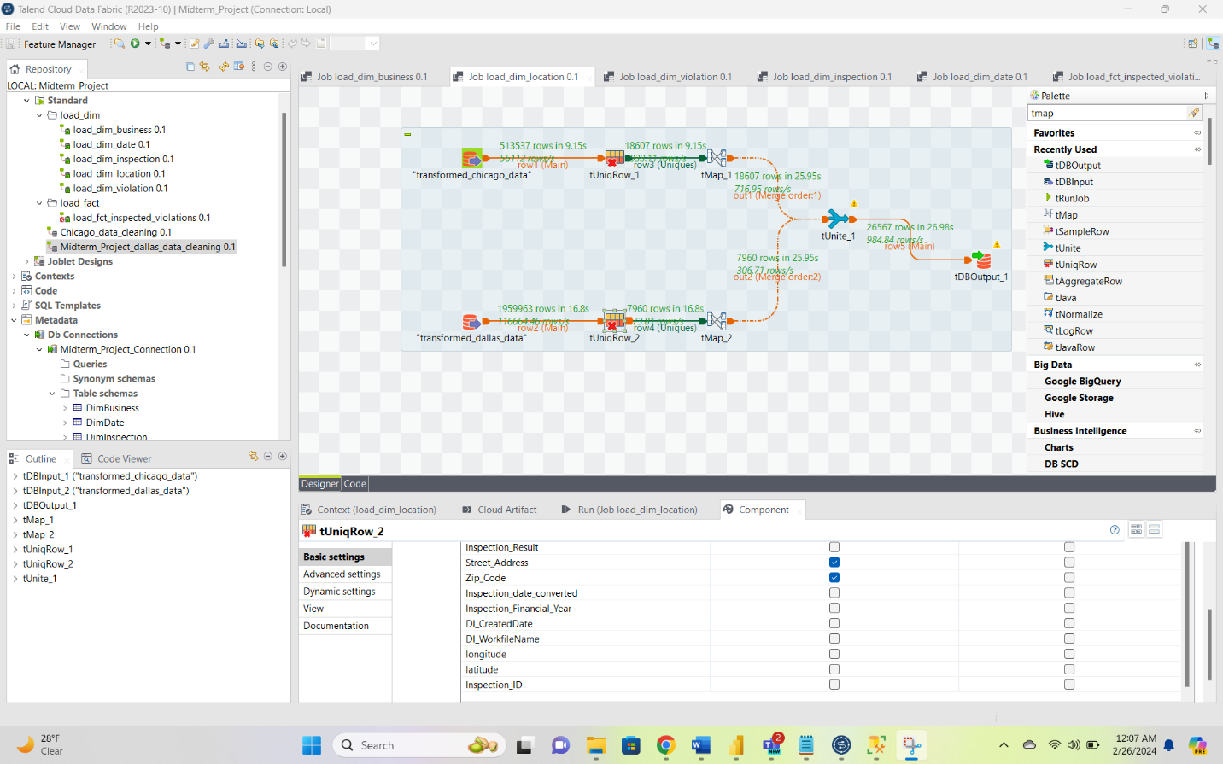

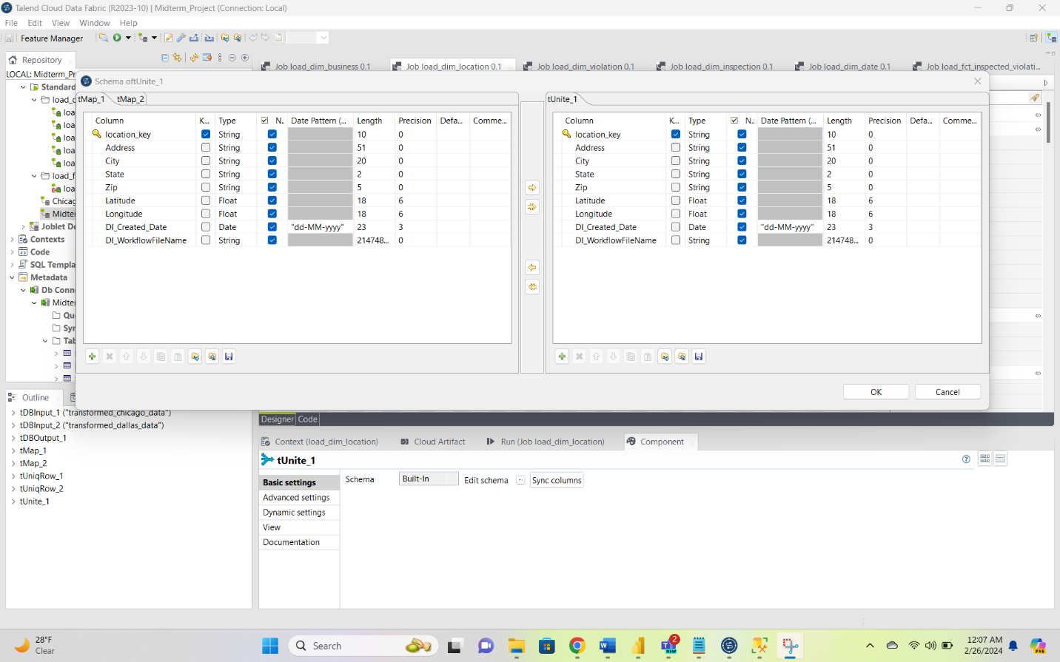

1. Used TUniqRow to get only the unique location records from the Chicago data based on address and zip column and same for that of the Dallas data. Had to do this since normalized records contained repetitive location values which in turn should be associated with the same location_key.
2. Later used the TUnite Tool to map the columns with appropriate data type by editing the schema so that we can apply a union on both the tables. Later exported that data as the DimLocation table to our project database provided **location_key** as the primary key.

**Loading of DimBusiness**

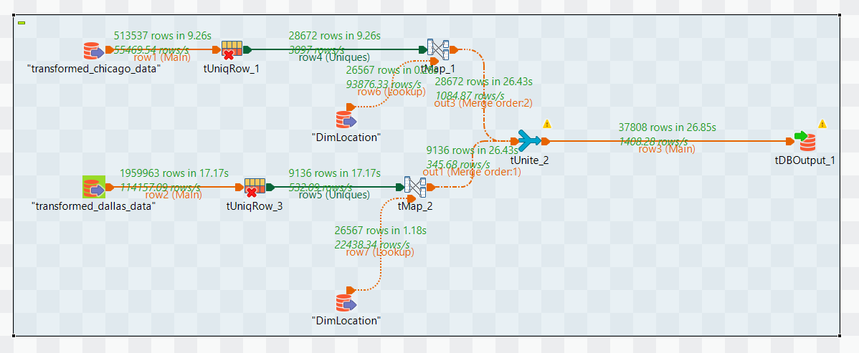

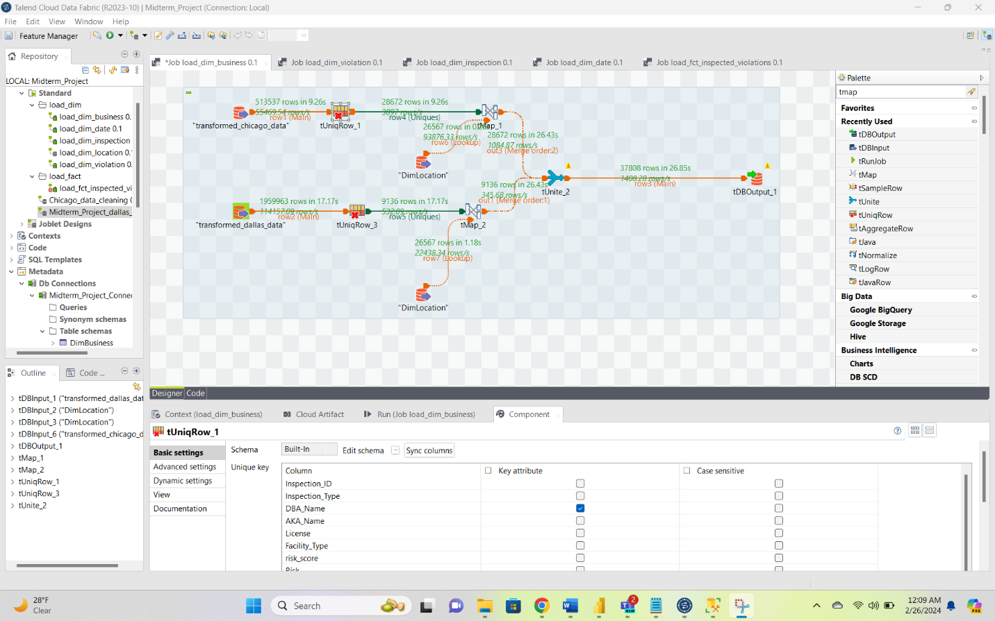

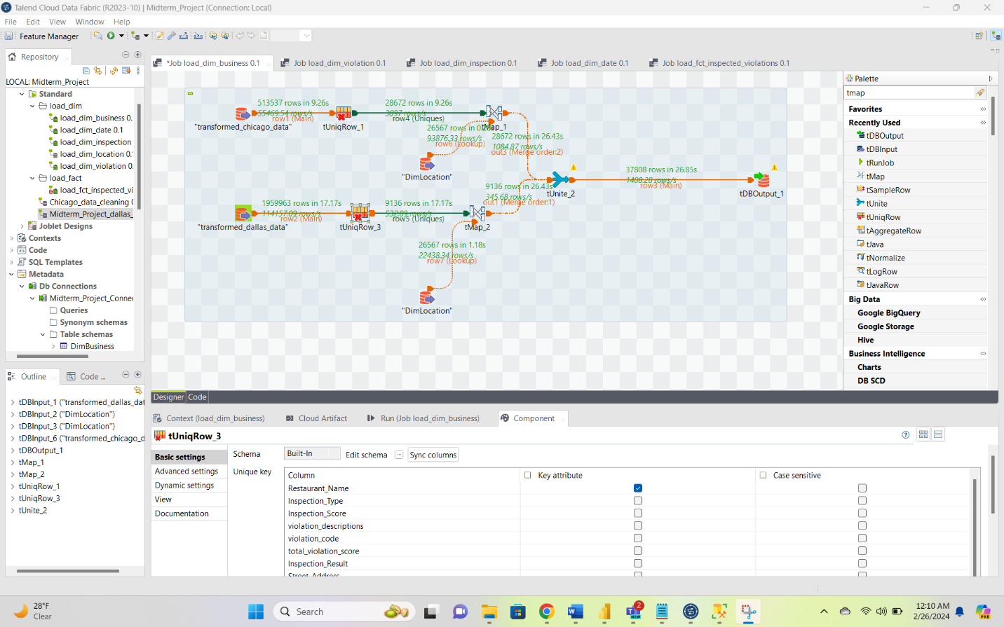

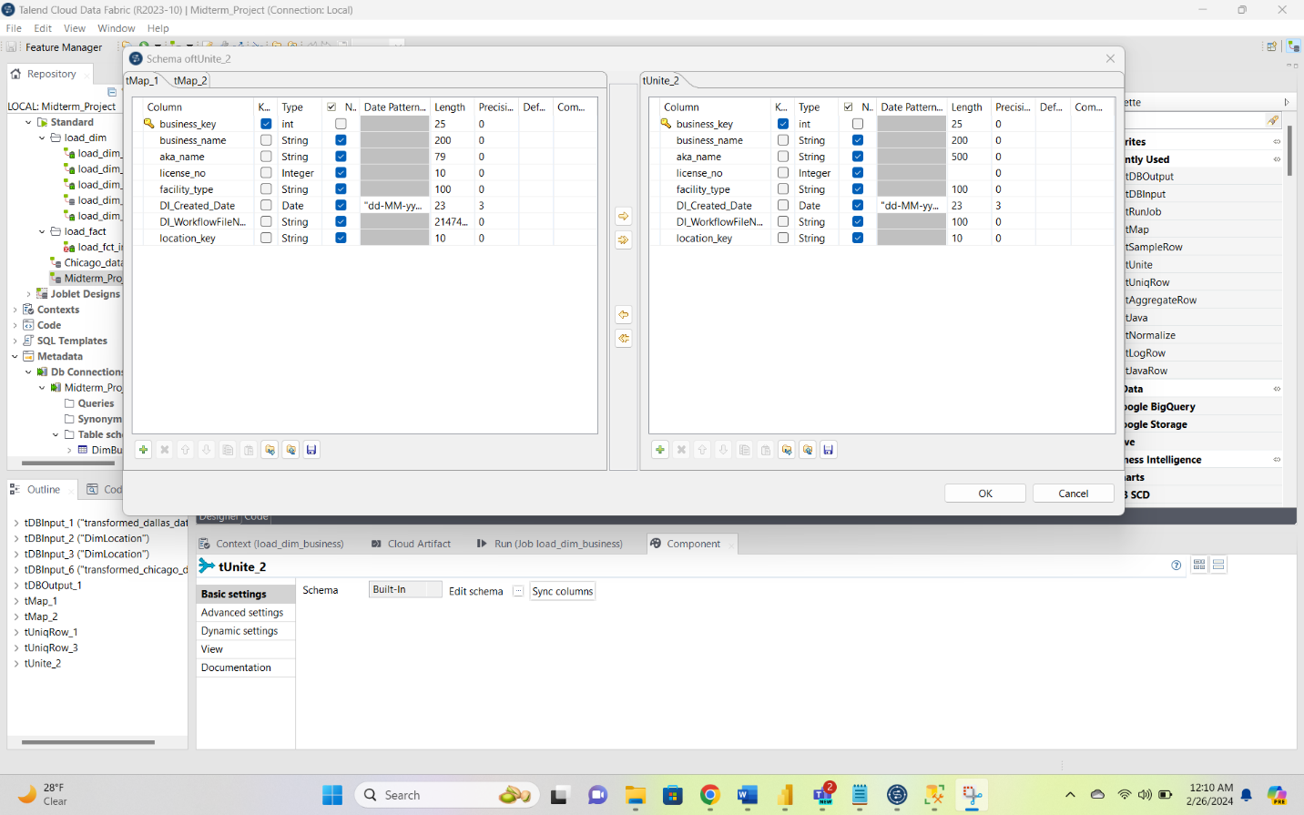

1. Used TUniqRow to get only the unique location records from the Chicago data based on Restaurant Name and DBA Name for that of the Dallas data. Had to do this since records contained repetitive restaurant/DBA values which in turn should be associated with the same business_key.
2. Later used the TUnite Tool to map the columns with appropriate data type by editing the schema so that we can apply a union on both the tables. Later exported that data as the DimBusiness table to our project database provided **business_key** as the primary key.

**Loading of DimDate**

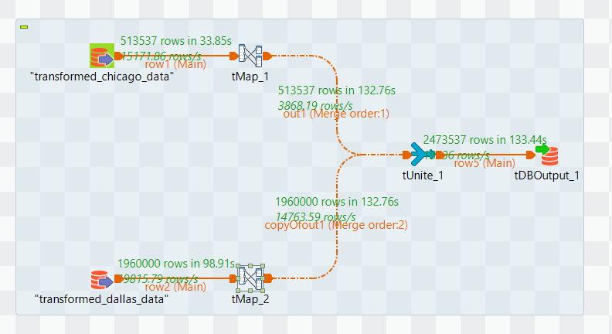

**Loading of DimInspection**

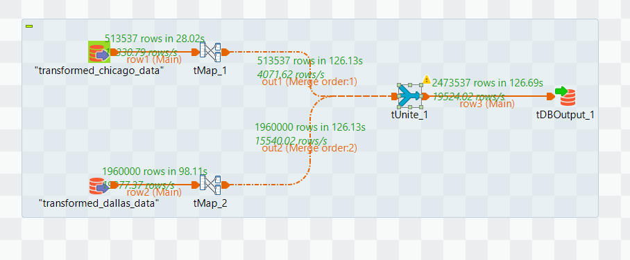

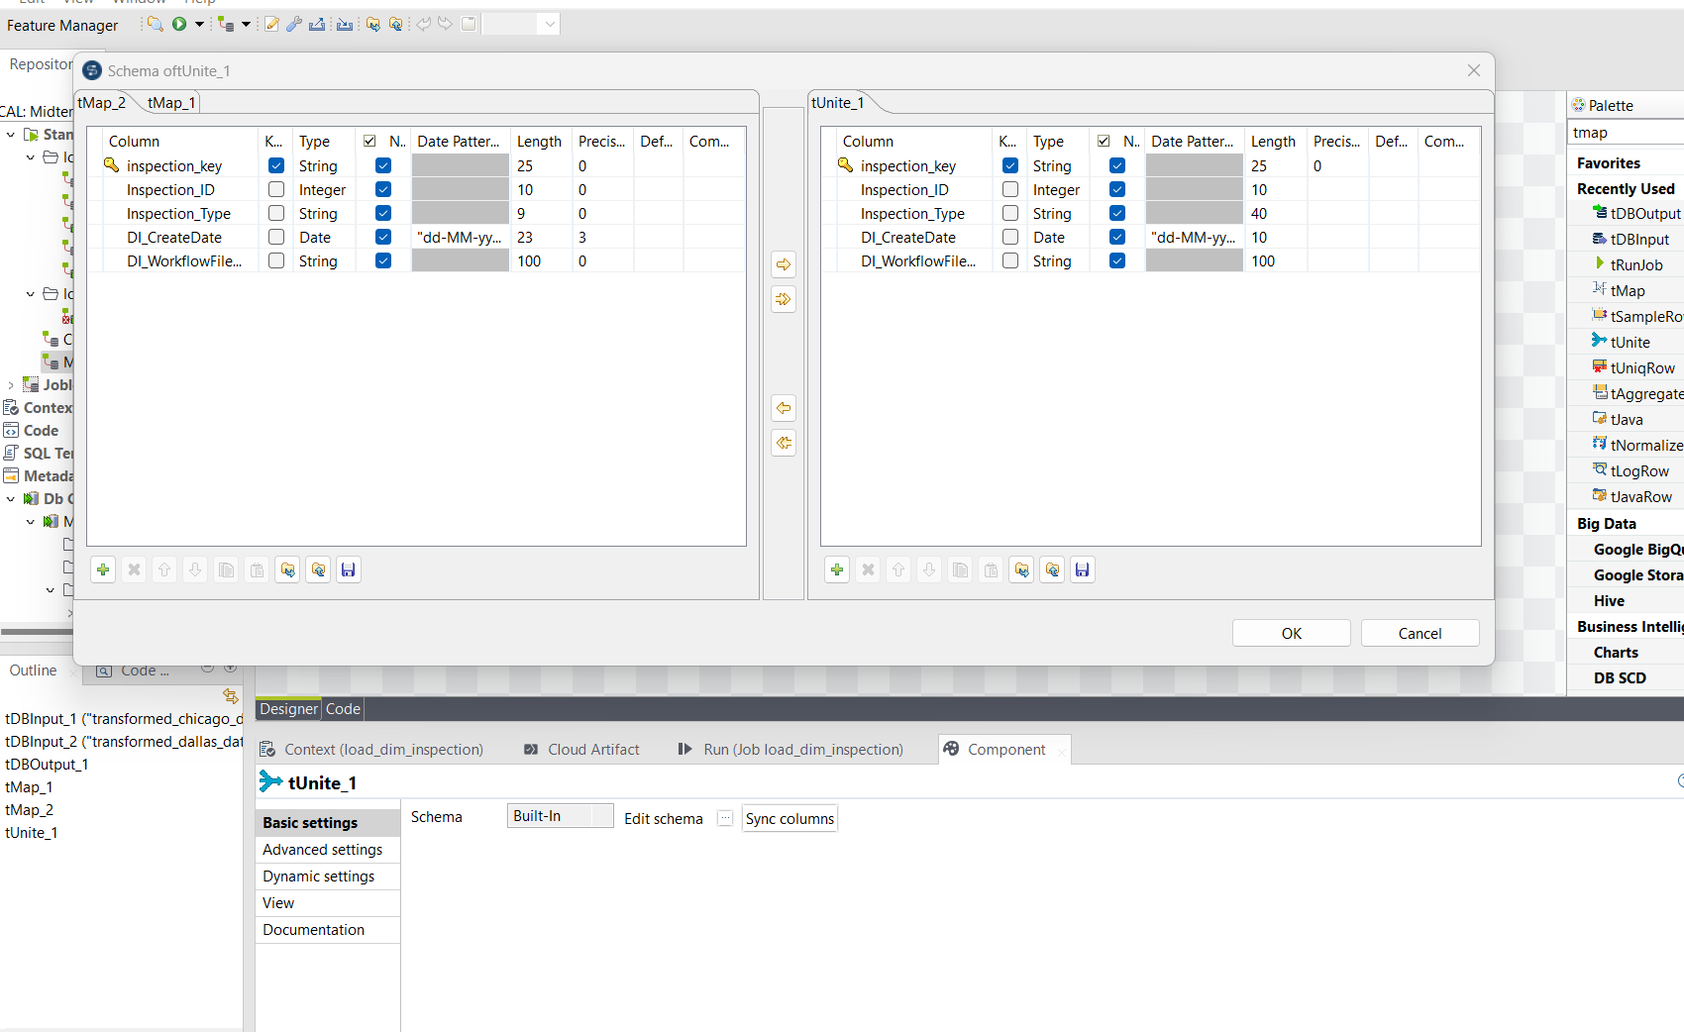

1. There was a unique inspection id present for all the records of the Chicago Dataset. We generated new non-repetitive inspection ids for that of the Dallas data.
2. Later used the TUnite Tool to map the columns with appropriate data type by editing the schema so that we can apply a union on both the tables. Later exported that data as the DimInspection table to our project database and provided **inspection_key** as the primary key.

**Loading of DimViolation**

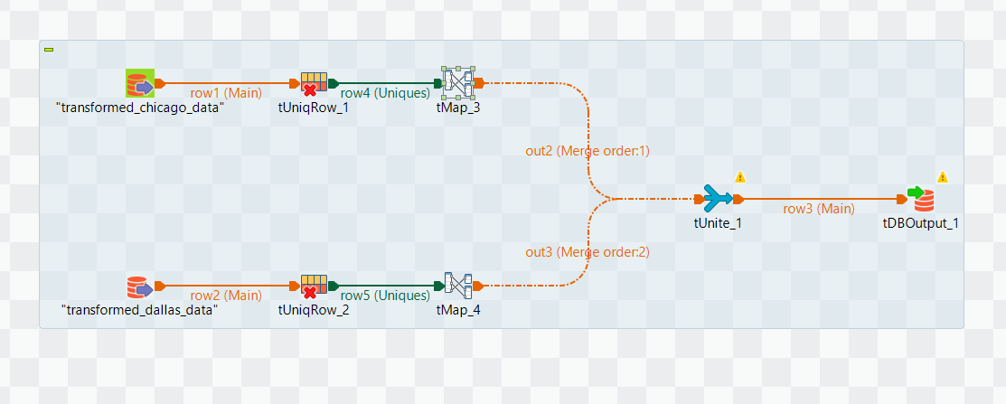

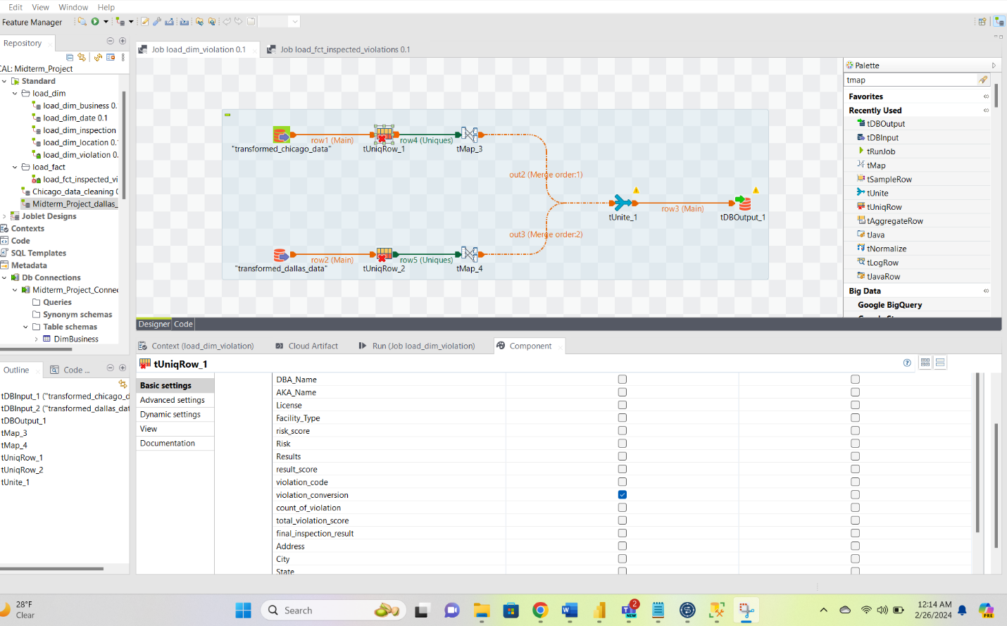



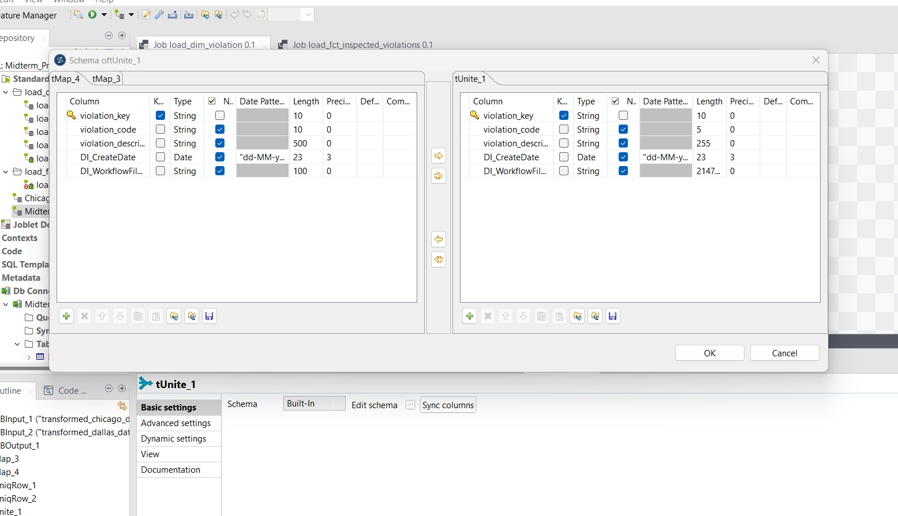

1. There was a unique violation description and code present for all the records of the Chicago & Dallas Dataset. We generated new non-repetitive violation ids for that of the unique violation description records. Used the TUniqRow tool for the same.
2. Later used the TUnite Tool to map the columns with appropriate data type by editing the schema so that we can apply a union on both the tables. Later exported that data as the DimViolation table to our project database and provided **violation_key** as the primary key.

**Loading of the Fact table**

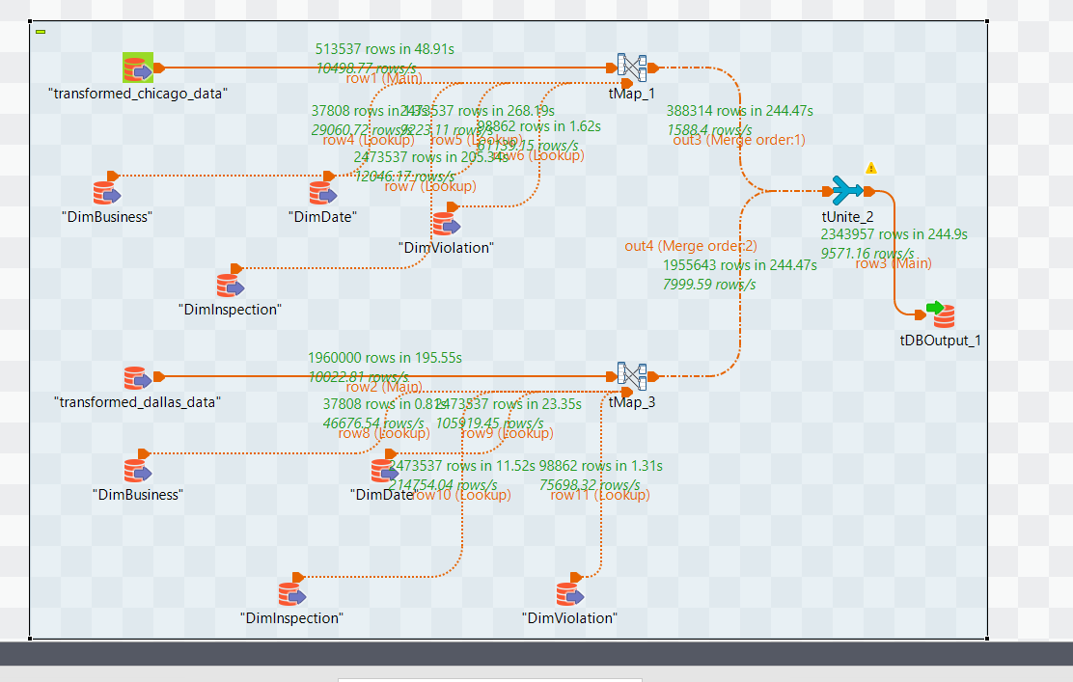

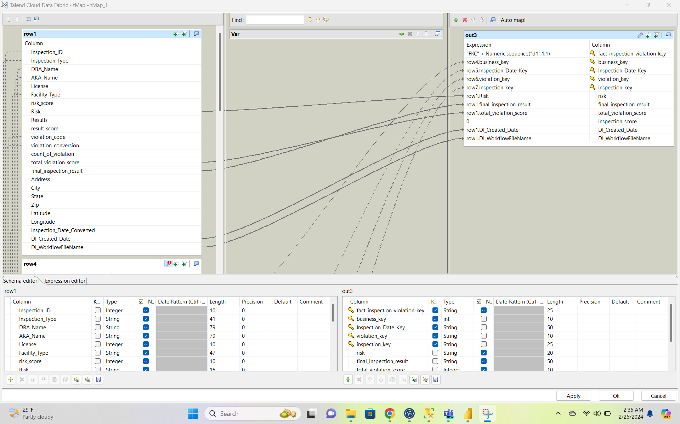

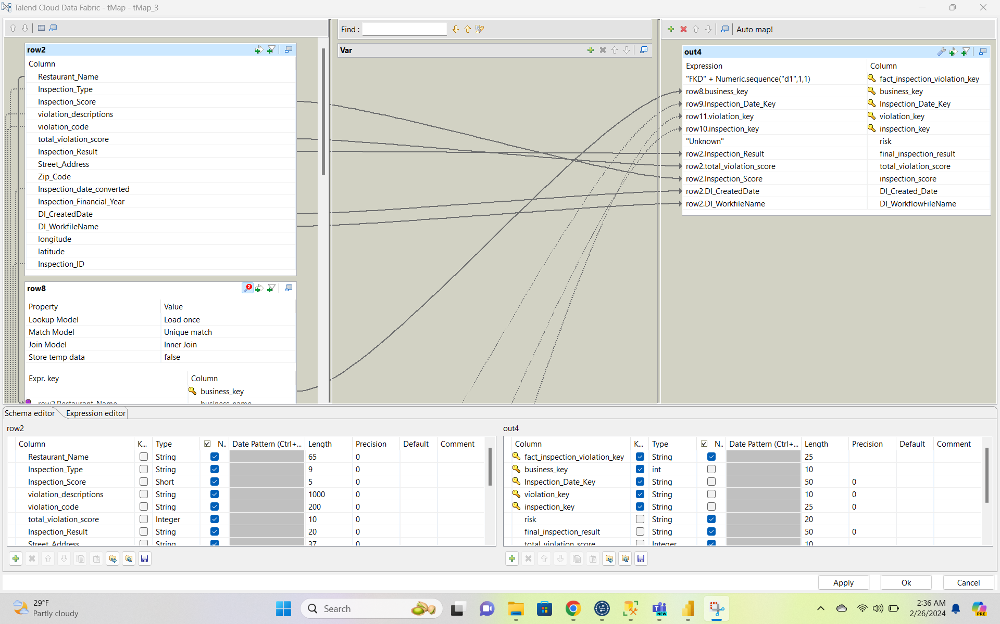

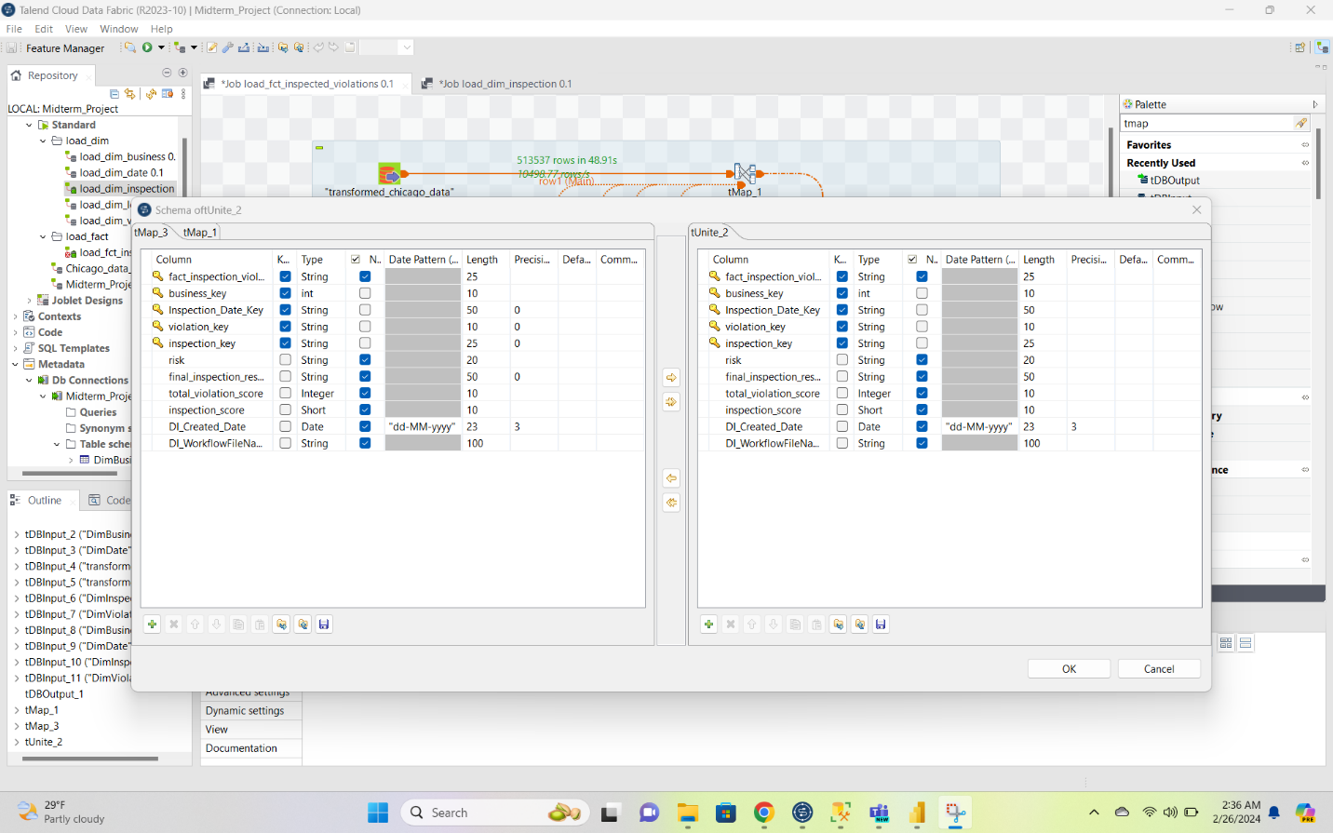

1. Took all the result related facts such as inspection score, final inspection result, risk, total violation score etc and loaded those things by look-up of columns based on the other dimension tables. Also mapped the primary keys of all the other dimension tables to this fact table so that they act as the foreign keys while querying the data.
2. Added a unique fact_inspection_violation_key as the primary key for the table and loaded the table to the DB output through the TUniteRow Tool.

**SQL Count Verifications for all loaded tables:**

DimBusiness

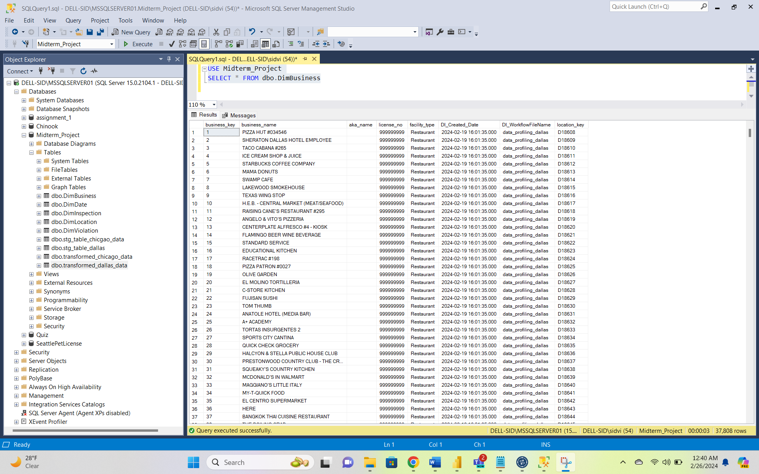

DimInspection:

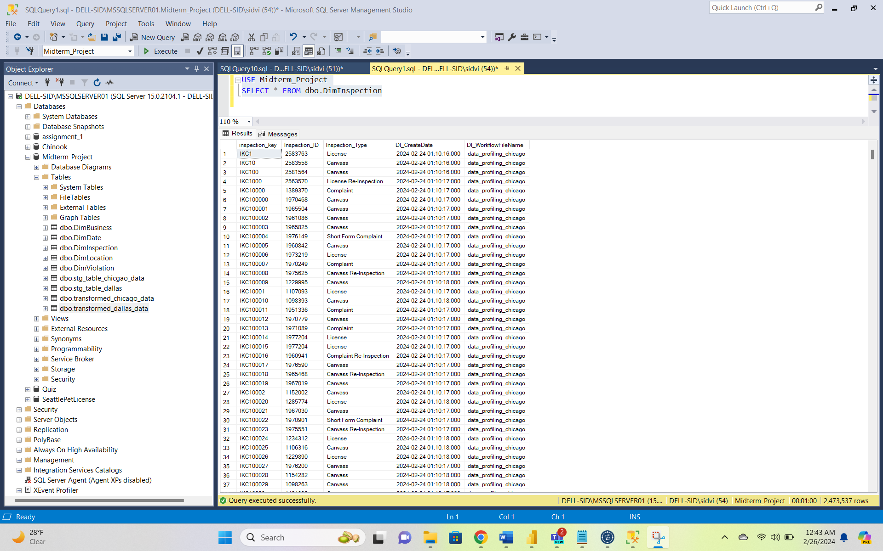

DimLocation:

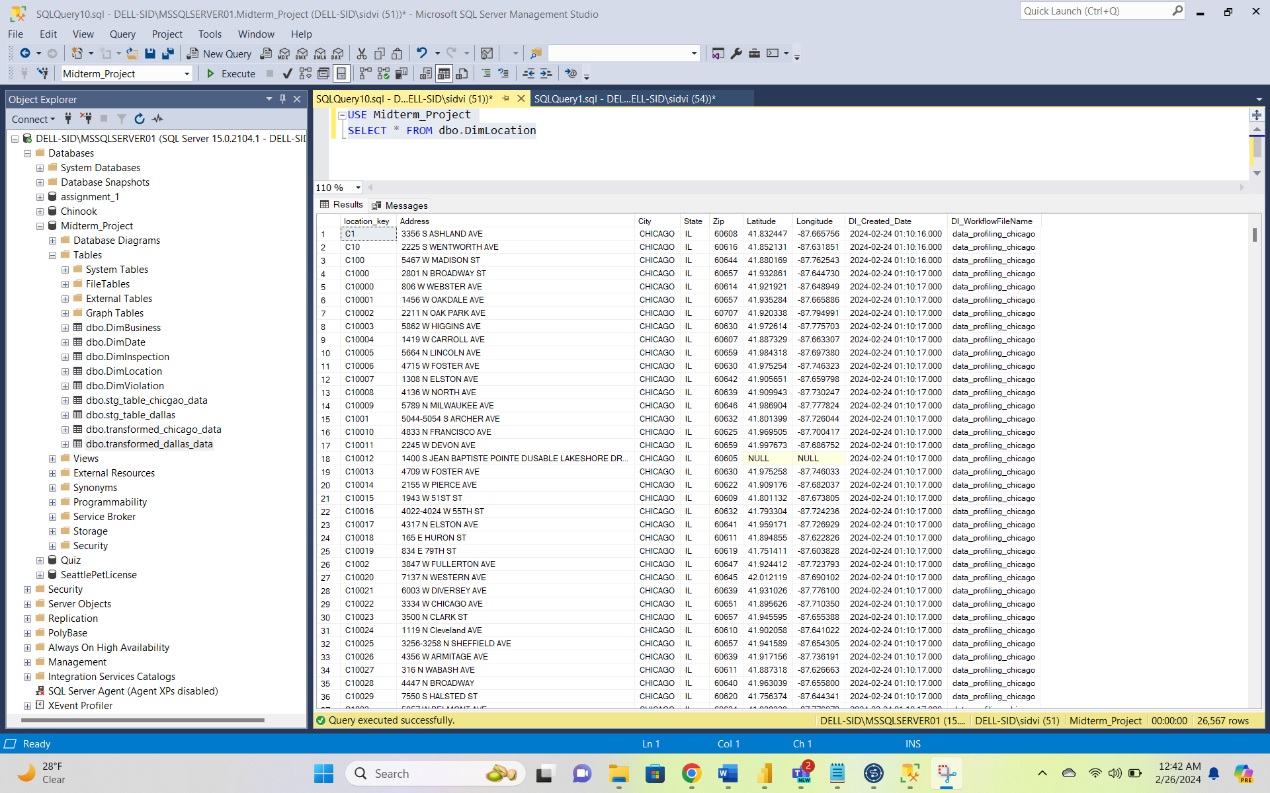

DimViolation:

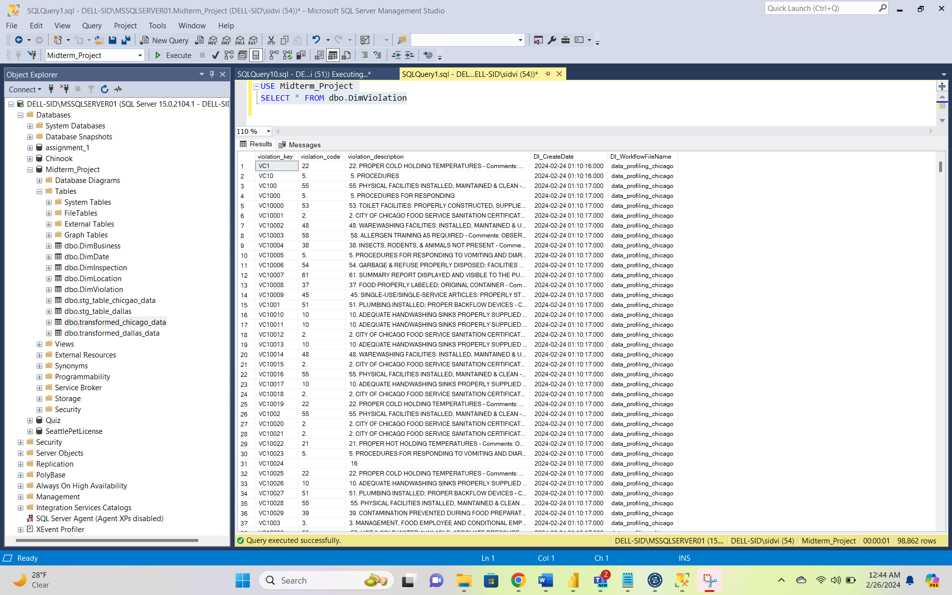

transformed_dallas_data:

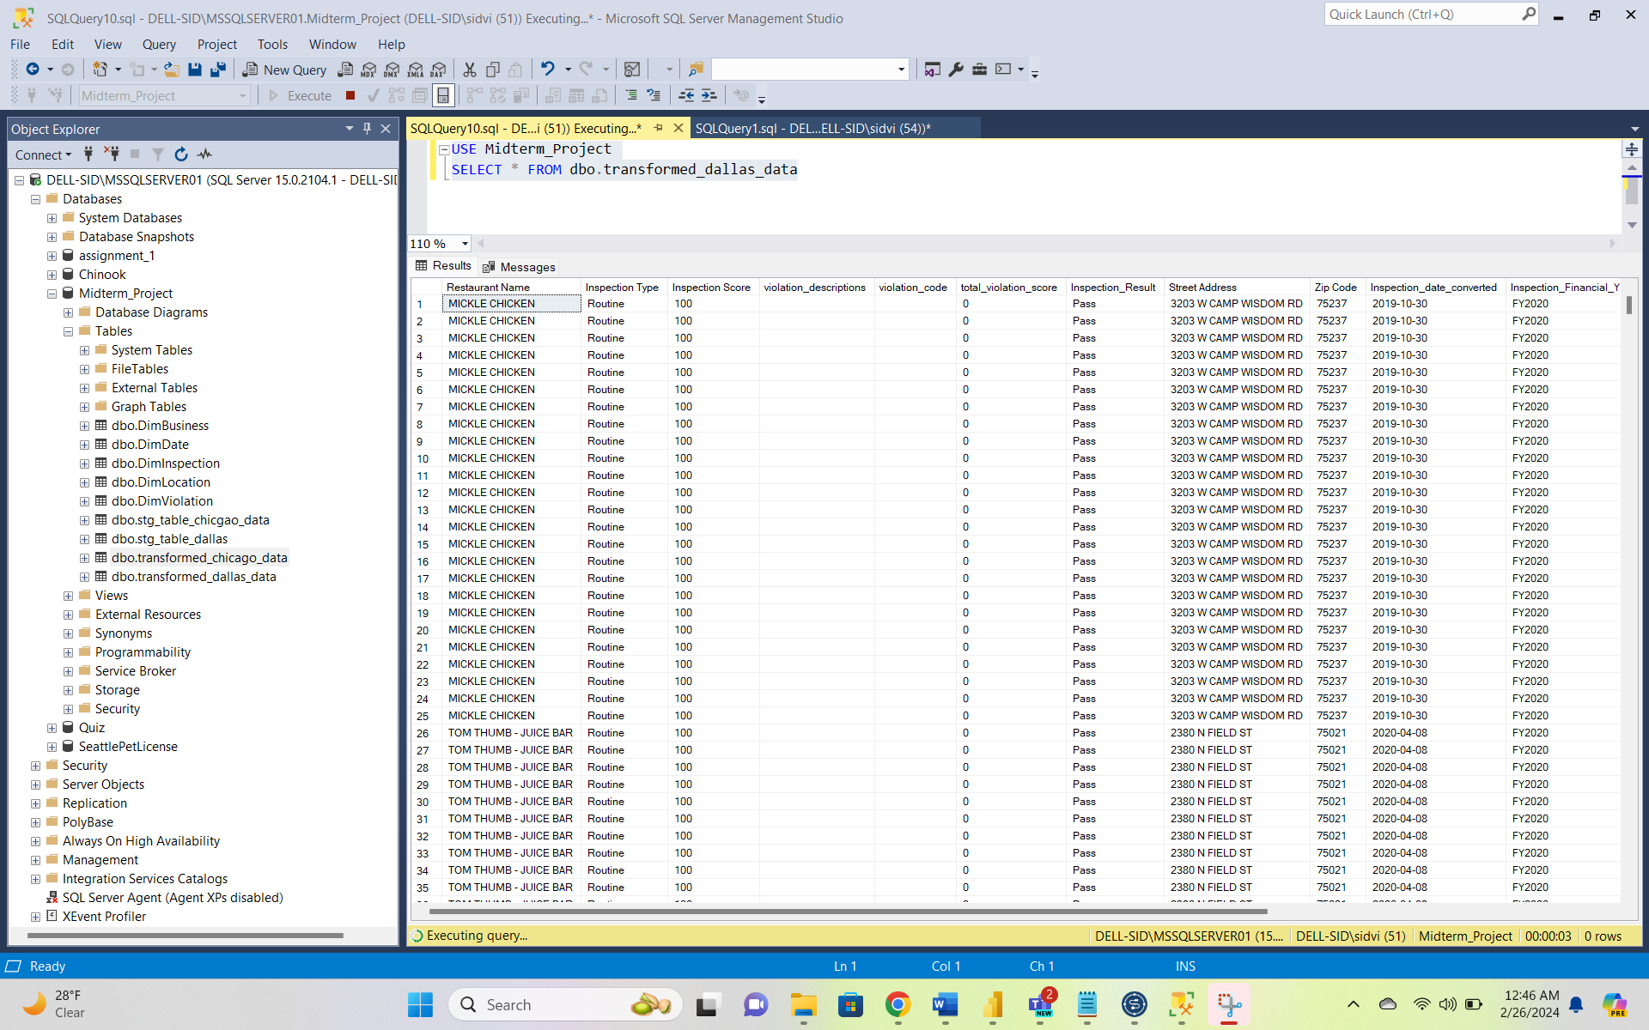

transformed_chicago_data:

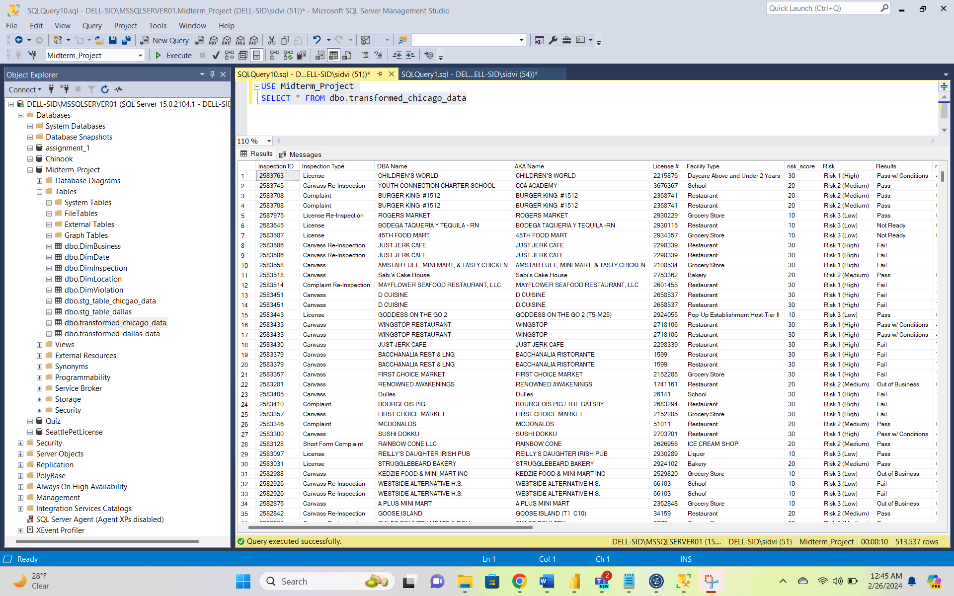

fct_inspection_violation:

